Summary-

We tried different fusions of pyramid levels from the HR and LR images. We deconstructed each image (after scaling) into 8 levels, and tried different combinations of the levels.

For reference, here are the images we used:

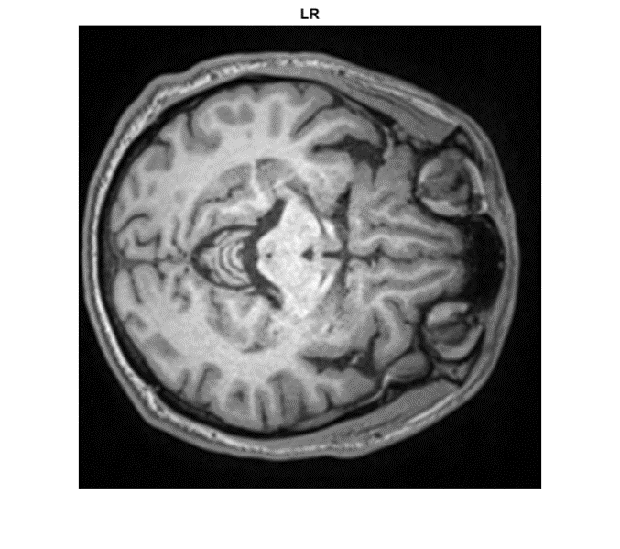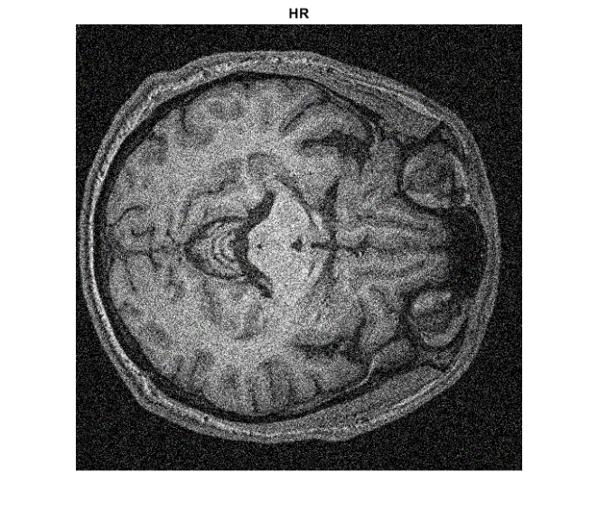

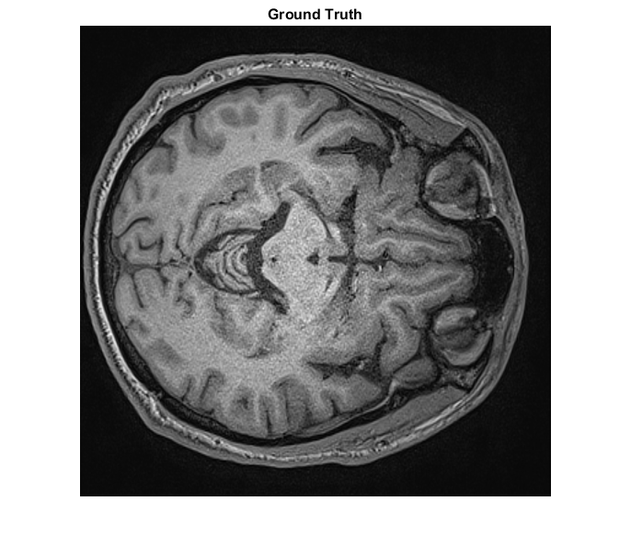

Bellow you can see a graph of PSNR for the different combinations. The blue plot represents an image which initially contained all levels from the LR pyramid. Each time we replaced one more level **from the bottom up** with the corresponding level from the HR pyramid, until at n=8 we got the HR image. (all levels were replaced with levels from the HR pyramid)

The red plot is the opposite of that.

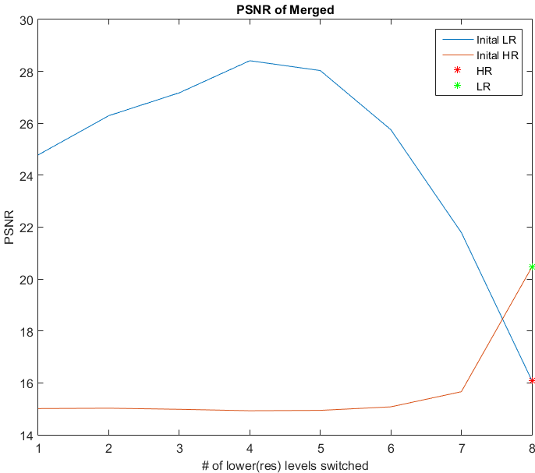

As you can see, the highest PSNR is achieved for an image created by reconstructing a pyramid made up of: bottom 4 levels from the HR pyramid, top 4 levels from the LR pyramid.

Bellow are some visual examples of the merges:

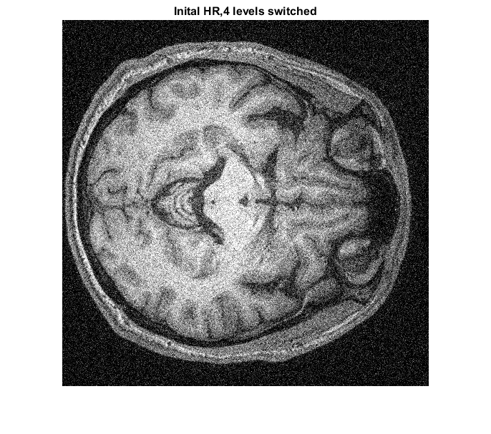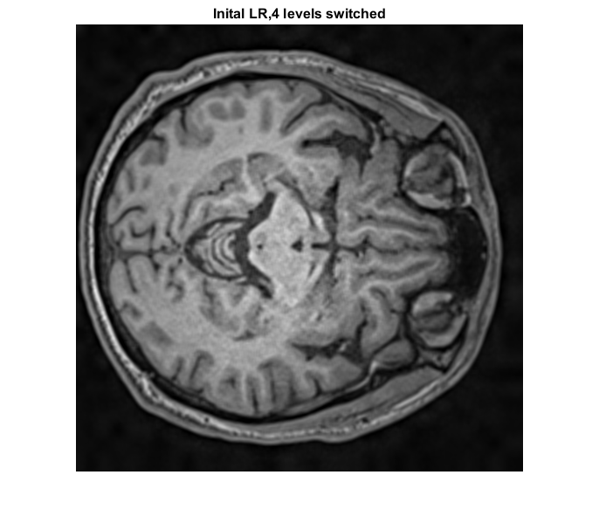

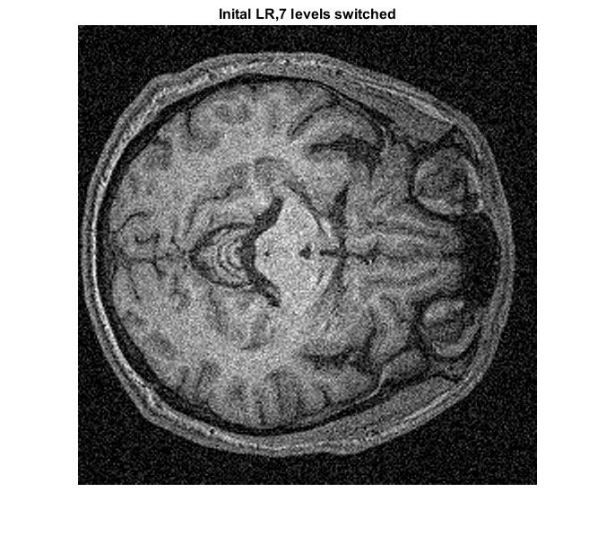

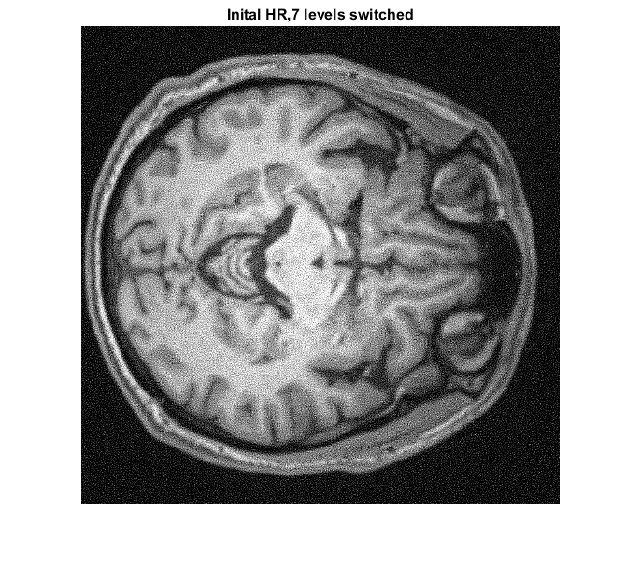

Next, we tried running BM3D and BM3D tweaked on some of the merged images.

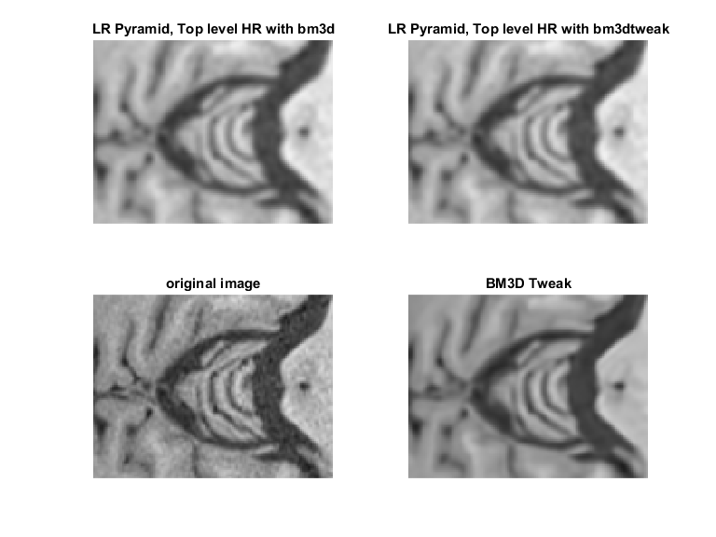

The bottom right image in the above is just BM3D tweaked on the original HR image with LR guidance, no pyramid games. The top images are BM3D and BM3D Tweaked respectively on an image constructed of bottom 7 level from the LR pyramid and top level from the HR pyramid. We chose this combination because the merged image looked sharp to us, and with relatively low noise.

The graph bellow is like the first graph presented in this document, only here we ran BM3D and BM3D on **the final product of the merge**.

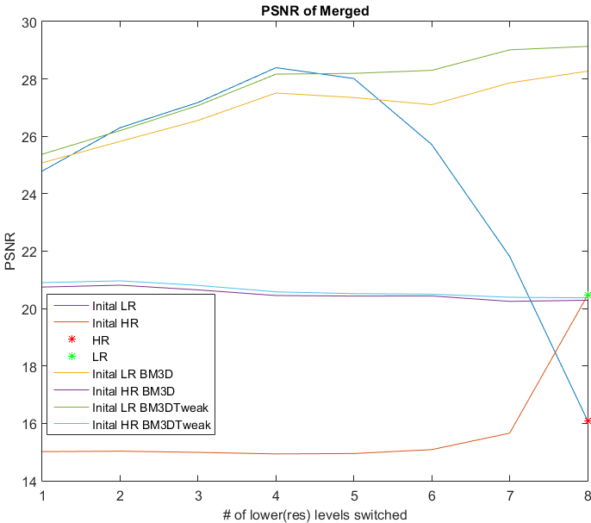

For example, the green plot shows: we took the LR pyramid, and each time replaced another level with a level from the HR pyramid. (from the bottom up) Then, we ran BM3D on the reconstructed pyramid.

**It is interesting to note that the highest PSNR is achieved for BM3D Tweaked on the HR image!** (8 levels were replaced, meaning the pyramid contains only levels from the HR pyramid)

So, it seems like these different merges and combinations do no improve the PSNR over BM3D Tweaked.

It is worth noting however that some combinations achieved visual quality that to our naked eye looked just as good at BM3D Tweaked.

Next, we wanted to analyze some statistics about the block matching done in BM3D. The motivation for this being perhaps finding a smart way to aggregate blocks from the different images to achieve a better, merged image.

We ran block matching on 3 reference blocks from 3 different coordinates in the image: a smooth area, a detailed area and a small feature.

In each are, we ran BM on:

* The original, ground truth image
* The HR image
* The LR image
* Each level of the LR pyramid
* Each level of the HR pyramid

For each of these reference blocks, we calculated the average and variation of the distance of the matched blocks from the reference block.

The images of the blocks are available under Project_A\Data\bm_figures\sigma_noise40-sigma_blur5-kernel_size5\smooth (or detailed_point or feature respectively)

The repository is available here: <https://github.com/noaen/Project_A.git>